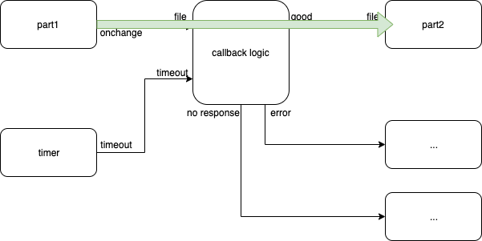
Fig. <$n:figure:HappyPath> Happy Path

The green arrow shows what happens when everything goes according to plan.

